MINI-PROJECT REPORT

ON

**wireless Notice Board using Bluetooth**

## SUBMITTED BY

**Jujare Rutuja Prakash ( ROLL No.: 3224)**

**Kasture Dhanshree ( ROLL No.: 3225)**

**Kothwade Prajakta ( ROLL No.: 3231)**

UNDER THE GUIDANCE OF

# PROF. S. G. DUBE

###### 

DEPARTMENT OF

ELECTRONICS AND TELECOMMUNICATION ENGINEERING

**MKSSS’s**

**Cummins College of Engineering for Women, Pune**

**(An Autonomous Institute Affiliated to Savitribai Phule Pune University)**

**(2018-2019)**

Wireless Notice Board using Bluetooth

Jujare Rutuja ( ROLL No.: 3224)

Kasture Dhanshree ( ROLL No.: 3225)

Kothwade Prajakta ( ROLL No.: 3231)

**Under the guidance of**

**PROF. S. G. DUBE**



**DEPARTMENT OF ELECTRONICS AND TELECOMMUNICATION ENGINEERING**

## MAHARSHI KARVE STREE SHIKSHAN SAMSTHA’S

**CUMMINS COLLEGE OF ENGINEERING FOR WOMEN**

**KARVE-NAGAR, PUNE-411 052. (INDIA)**

**(An Autonomous Institute Affiliated to Savitribai Phule Pune University)**

**MAHARSHI KARVE STREE SHIKSHAN SAMSTHA’S**

**CUMMINS COLLEGE OF ENGINEERING FOR WOMEN**

**KARVE NAGAR, PUNE-411 052. (INDIA)**

**(An Autonomous Institute Affiliated to Savitribai Phule Pune University)**

**CERTIFICATE**

This is to certify that the Mini Project work entitled

**Wireless Notice Board using Bluetooth**

is a bonafide record of project work carried out in this institute

by

##### Jujare Rutuja( ROLL No.- 3224 )

##### Kasture Dhanashree ( ROLL No.-3225 )

##### Kothwade Prajakta( ROLL No. –3231)

in partial completion of the term work for the Third Year B.Tech.

in

Electronics and Telecommunication Engineering

in the academic year 2018-2019.

This Mini-Project Report is a record of their own work carried out under our

supervision and guidance.

**Prof. S. G. Dube Dr. Prachi Mukherji Dr. M. B. Khambete**

**ACKNOWLEDGEMENT**

We would like to express our sincere gratitude towards our mini-project guide **Prof. S. G. Dube** for his constant encouragement and valuable guidance during the completion of this mini-project work.

We would also like to thank **Dr. Prachi Mukherji (H.O.D.,E&Tc)** for her continuous valuable guidance, support, valuable suggestions and her precious time in every possible way in spite of her busy schedule throughout our project activity.

We take this opportunity to express our sincere thanks to all the staff members of E&Tc. Department for their constant help whenever required. Finally; we express our sincere thanks to all those who helped us directly or indirectly in many ways in completion of this mini-project work.

Student Names

1)Name: Rutuja Jujare ,Roll No.-3224

2) Name:Dhanashree Kasture ,Roll No.-3225

3)Name:Prajakta Kothwade,Roll No.-3231

**ELECTRONIC NOTICE BOARD**

**TABLE OF CONTENTS**

**1.Introduction**

**2.Objective**

**3.Components Description**

**4.Procedure**

**5.System Specifications:**

**i)Software Used**

**ii)Code and Simulation**

**iii)Block Diagram.**

**iv)Flowchart**

**v)Circuit Diagram and Working Principle**

**6.Advantages**

**7.Future Scope**

**8.Applications**

**9.Conclusion**

**INTRODUCTION:**

The various organisations, institutes use circulars and notice boards for conveying information to the students. This methodology takes additional time for updating also many students may not be aware of the information displayed on notice boards due to non-eye catching notices. Digital Notice board is one of the ways of displaying notices in which the notices are displayed on a LCD Display Screen. These notices are changed dynamically .Whenever a notice is passed it can be directly displayed on the Digital notice board, without efforts like printing on a paper and then attaching it manually to the notice board. Many of the students don’t have a habit of continuously checking and reading the notice board. But using a digital notice board we can directly display it on a big LCD display board, which can be easily seen and read by many students at a time. Hence most of the students can quickly come to know what is the notice and the important message is conveyed to all. The notice keeps on rolling over and over. To provide the fastest medium that notifies and conveys important notices and messages, from administration to students within colleges and in bigger organizations. Now-a-days the general mass prefer communicating while on the move therefore landlines usage has been drastically reduced. Notice boards are one of the widely used ones ranging from primary schools to major organizations to convey messages at large. A lot of paper had been used and which is later wasted by the organizations. This in turn leads to a lot of deforestation thus leading to global warming. Small innovative steps in making use of technology for regular purposes would have an adverse effect on the environment issues which we are presently concerned about.

The BLUETOOTH module receives a message from the authorized mobile phone and the message is extracted by the arduino from the BLUETOOTH module and is displayed on the LCD display. And for the acknowledgement LCD display is used. This proposed system has many upcoming applications in educational institutions and organizations, crime prevention, traffic management, railways, advertisements etc. By using this system we can avoid many dangers and awareness of emergency situations.

**Objective:**

Observing the current technology trend and the need of digital notice boards that are smart enough is essential. The main objective of the system will be,

1. To develop wireless technology for users.

2. To design a simple user friendly system.

3. To easily keep track of notice boards by the user with respect to date and time. 4. To develop a dynamic notice model.

4. To develop a dynamic notice structure.

**Components Description:**

This is an Electronic Wireless Notice Board project. We have made a prototype with an Arduino Uno Board. It has a Bluetooth Module that can be connected via a smartphone. User can send text from his/her smart phone with a simple application to show it on the display. In this case, the Bluetooth module that we used (HC-05) has an open source free android application (Arduino Bluetooth Controller) to send serial input (text) to the Arduino board. We received the serial input and showed on a 16x2 LCD Display. It can display at most 32 characters. For a prototype, we used a smaller and simpler display to reduce the cost and complexity. We used a loop to show the outputs iteratively and it continues to show the outputs until the user wants it to stop. By giving a single character input “x”, the output iteration will stop and the display will be cleared. If then the user gives more input, it starts iterating again. Every new input will add at the end of the loop. So, the display will continue to show the inputs that the user gives one by one.

We used:

* Arduino Uno Board
* 16x2 LCD display
* Bluetooth (HC-05)
* Wires

By using these components we implement our project as Electronic Notice Board in Proteus Software.

**1.Arduino UNO Board:**

## Pins:

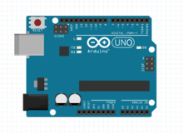

**Arduino UNO**

### General pin functions:

* **LED**: There is a built-in LED driven by digital pin 13. When the pin is high value, the LED is on, when the pin is low, it is off.
* **VIN:** The input voltage to the Arduino board when it is using an external power source (as opposed to 5 volts from the USB connection or other regulated power source). You can supply voltage through this pin, or if supplying voltage via the power jack, access it through this pin.
* **5V**: This pin outputs a regulated 5V from the regulator on the board. The board can be supplied with power either from the DC power jack (7 - 20V), the USB connector (5V), or the VIN pin of the board (7-20V). Supplying voltage via the 5V or 3.3V pins bypasses the regulator, and can damage the board.
* **3V3**: A 3.3 volt supply generated by the on-board regulator. Maximum current draw is 50 mA.
* **GND**: Ground pins.
* **IOREF**: This pin on the Arduino Uno board provides the voltage reference with which the microcontroller operates. A properly configured shield can read the IOREF pin voltage and select the appropriate power source, or enable voltage translators on the outputs to work with the 5V or 3.3V.
* **Reset:** Typically used to add a reset button to shields that block the one on the board

### 

### Special pin functions:

Each of the 14 digital pins and 6 analog pins on the Uno can be used as an input or output, under software control (using pinMode(), digitalWrite(), and digitalRead() functions). They operate at 5 volts. Each pin can provide or receive 20 mA as the recommended operating condition and has an internal pull-up resistor (disconnected by default) of 20-50K ohm. A maximum of 40mA must not be exceeded on any I/O pin to avoid permanent damage to the microcontroller. The Uno has 6 analog inputs, labeled A0 through A5; each provides 10 bits of resolution (i.e. 1024 different values). By default, they measure from ground to 5 volts, though it is possible to change the upper end of the range using the AREF pin and the analogReference() function.

In addition, some pins have specialized functions:

* Serial / [UART](https://en.wikipedia.org/wiki/UART): pins 0 (RX) and 1 (TX). Used to receive (RX) and transmit (TX) TTL serial data. These pins are connected to the corresponding pins of the ATmega8U2 USB-to-TTL serial chip.
* External interrupts: pins 2 and 3. These pins can be configured to trigger an interrupt on a low value, a rising or falling edge, or a change in value.
* [PWM](https://en.wikipedia.org/wiki/Pulse-width_modulation) (pulse-width modulation): pins 3, 5, 6, 9, 10, and 11. Can provide 8-bit PWM output with the analogWrite() function.

* [SPI](https://en.wikipedia.org/wiki/Serial_Peripheral_Interface) (Serial Peripheral Interface): pins 10 (SS), 11 (MOSI), 12 (MISO), and 13 (SCK). These pins support SPI communication using the SPI library.

**2. 16*2 LCD Display:**

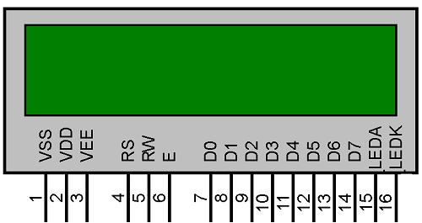

The term LCD stands for liquid crystal display. It is one kind of electronic display module used in an extensive range of applications like various circuits & devices like mobile phones, calculators, computers, TV sets, etc. These displays are mainly preferred for multi-segment light-emitting diodes and seven segments. The main benefits of using this module are inexpensive; simply programmable, animations, and there are no limitations for displaying custom characters, special and even animations, etc.

**Bluetooth(HC-05):**

HC‐05 module is an easy to use Bluetooth SPP (Serial Port Protocol) module,designed for transparent wireless serial connection setup. The HC-05 Bluetooth Module can be used in a Master or Slave configuration, making it a great solution for wireless communication. This serial port bluetooth module is fully qualified Bluetooth V2.0+EDR (Enhanced Data Rate) 3Mbps Modulation with complete 2.4GHz radio transceiver and baseband.

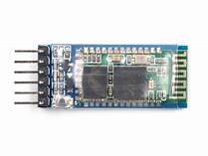

**Procedure:**

The LCD’s are very good as they can be used in better way to display some of the characters including the upper case and the lower case and also the numbers.

Step 1 :Ground pin of the LED’s will go to the ground of the arduino.

Step 2 :For the preset wiring the pin 1 will go to the ground and the other pin will go to the positive. So it will give the output at the center voltage.

Step 3 :We included a liquid crystal library in our Arduino code in order to write a program for LCD display.

Step 4. :We downloaded the app called Arduino Bluetooth Controller from the Play Store.

**System Specifications:**

1.Software used

2.Flowchart

3.Code and Simulation

4.Block Diagram

5.Circuit Diagram and Working Principle

**1.Software Used:**

We are using arduino software for coding and Proteus for simulation.

1. Proteus 8.1
2. Arduino
3. Libraries included in proteus are arduino and bluetooth
4. Arduino Bluetooth controller app(Android)

**2.Flowchart:**

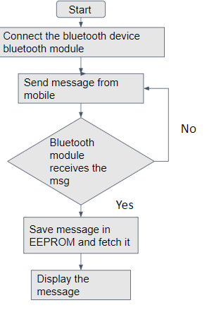

**3.Code and Simulation:**

#include<LiquidCrystal.h>

int temp=0,i=0,x=0,k=0;

char str[100],msg[32];

LiquidCrystal lcd(7,6,5,4,3,2);

void setup()

{

// put your setup code here, to run once:

lcd.begin(16,2);

Serial.begin(9600);

lcd.setCursor(0,0);

lcd.print("Wireless Notice");

lcd.setCursor(0,1);

lcd.print("Board using Bluetooth ");

delay(2000);

lcd.scrollDisplayLeft();

Serial.print("Enter your message\n");

}

void loop()

{

for(unsigned int t=0;t<60000;t++)

{

serialEvent();

if(temp==1)

{

x=0,k=0,temp=0;

while(x<i)

{

while(str[x]=='#')

{

x++;

while(str[x]!='*')

{

msg[k++]=str[x++];

}

}

x++;

}

msg[k]='\0';

lcd.clear();

lcd.print(msg);

delay(1000);

temp=0;

i=0;

x=0;

k=0;

}

}

lcd.scrollDisplayLeft();

}

void serialEvent()

{

while(Serial.available())

{

char ch=(char)Serial.read();

str[i++]=ch;

if(ch == '*')

{

temp=1;

lcd.clear();

lcd.print("Message Received");

delay(1000);

}

}

}

**4.Block Diagram**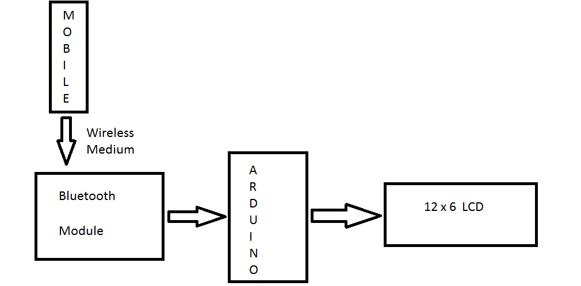

**5.Circuit Diagram:**

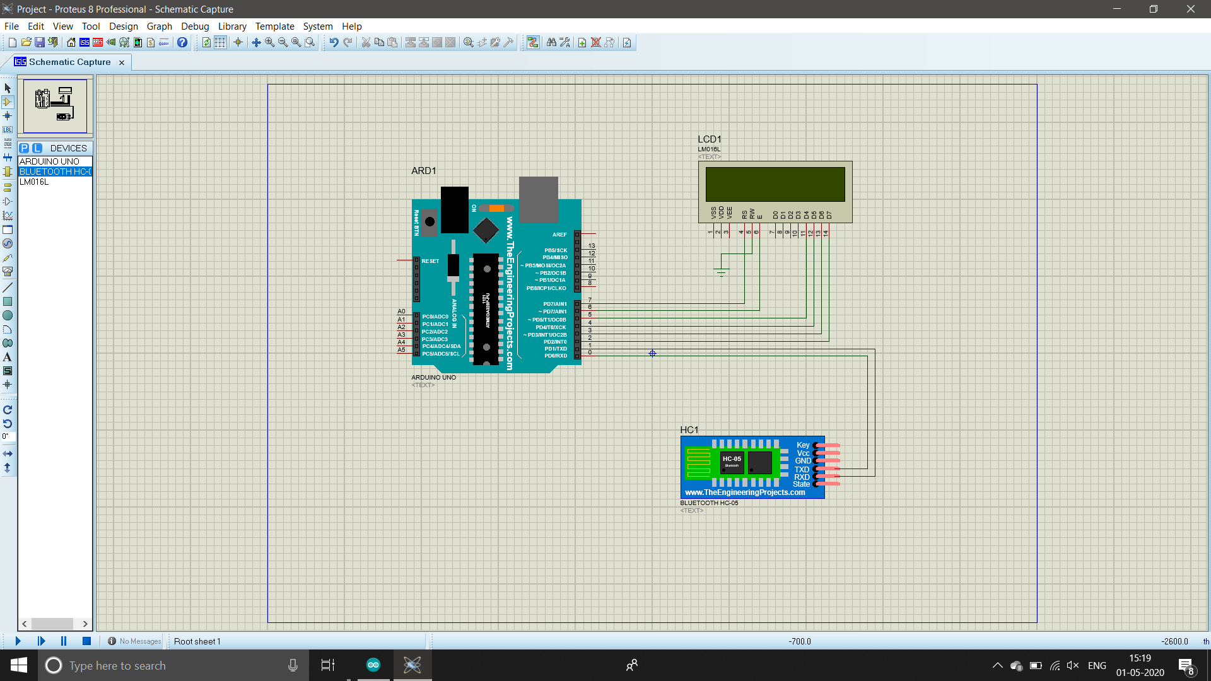

**Working Principle:**

Connections of Electronic Notice Board are simple as shown in above figure.Here a liquid crystal display (LCD) is used for displaying the “Notice” or message, which is sent through the mobile phone as SMS. RXD and TXD pins of Bluetooth are connected to Arduino from android mobile message which we want to display is sent to the Bluetooth module then it will be sent to the arduino then processing will occur. Finally message will be displayed on LCD display.

The bluetooth is a separate device between Arduino and Android. To the Arduino, it is just another serial device, indeed it is indistinguishable from the serial monitor and is used in the same way. To Android, it is just another Bluetooth device to be paired with, and the fact that there is an Arduino connected to it is immaterial. What this particularly means is:

1)Arduino is not involved with the pairing. It is just providing the power and, if there was another source of power, it needn’t be connected.

2)Consequently, a successful pairing is just between Bluetooth and Android, and does not guarantee successful communication with the Arduino.Similarly, the serial communication between Bluetooth and Arduino does not guarantee successful communication with Android. Note that there is no way of checking communication from Arduino to Bluetooth other than getting the signal all the way to Android. All the procedure for pairing and establishing connection is done at the Android end.

Proteus is an interpreted language: programs are loaded into memory, pre-compiled and run; since the number of built-in functions is large, execution speed is usually very good and often comparable to that of a compiled program.

**Android application:** The multi terminal is intended for simultaneous management of multiple accounts, such as WIFI and Bluetooth for which is mostly helpful for transmitting messages to the display. The new terminal successfully combines great functionalities that allow effective transferring with many accounts and with exceptional usabilityTerminal can easily get acquainted to this new program within a few minutes. We used Arduino Bluetooth controller application to connect with Arduino.

**6.Advantages:**

i)Low cost

ii)User friendly

iii)Easily available in market

iv)We can reprogram it 1000 times

**7.Future Scope:**

Our project Electronic Notice Board with display on scrolling LED display is intended to display and scroll the message given by the user. This system has Bluetooth interfaced to the Arduino. The Arduino is programmed in such a way that the message written in the program will display and scroll on the Notice Board.

This project can be extended using RS485 ,which also uses wired mechanism but the distance is far more than Rs232, also wireless technology Zigbee can be used.

**8.Applications:**

i)This technology can be implemented in schools,colleges etc.

ii)The proposed model is used in bus stations, railway stations, parks, etc. to display the messages wirelessly.

iii) This Project can also be used in colleges and organizations.

iv) The multi terminal is intended for simultaneous management of multiple accounts, such as WIFI and Bluetooth for which is mostly helpful for transmitting messages to the display.

**9.Conclusion:**

As the technology is advancing every day the display board systems are moving from Normal handwriting display to digital display. Further to Wireless display units. This develops a proto type laboratory model wireless notice board system with a BLUETOOTH connected to it, which displays the desired message of the user through an SMS in the most populated or crowded places. This proposed system has many upcoming applications in educational institutions and organizations, crime prevention, traffic management, railways, advertisements etc. Been user friendly, long range and faster means of conveying information are major bolsters for this application. By using this proposed methodology we can enhance the security system and also make awareness of the emergency situations and avoid many dangers.